**Create stored procedure to find greatest of three nos?**  
 procedure:  
 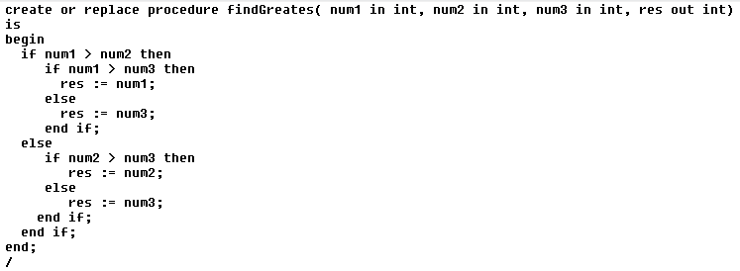

Output :   
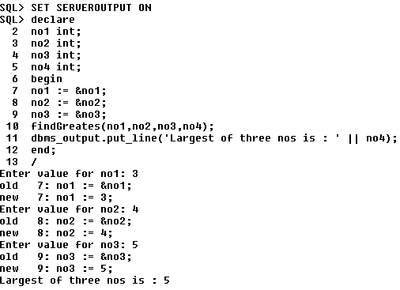

**Find average of 3 nos?**  
 Procedure:  
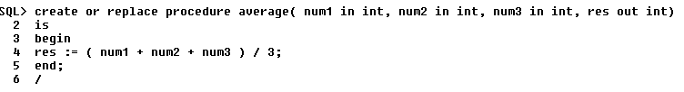

Output :

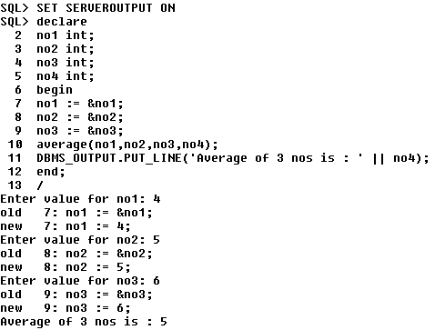

**Find factorial of num**  
Procedure:  
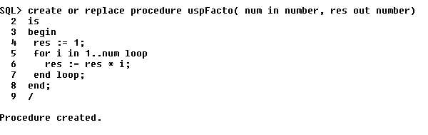

Output:  
